LAB 10:

Final Project: The RISC-Y Processor

Professor Ronald Mehler

ECE 526L

Spring 2018

Garen Nikoyan

5/10/2018

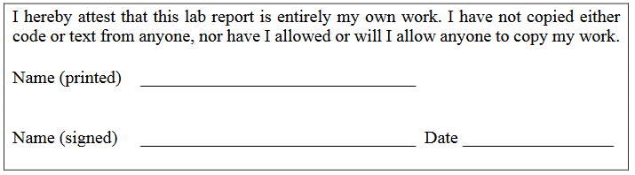

**Objective:**

The objective of this lab is to create a complete microcontroller, consisting of almost every other lab that was throughout the semester. This microcontroller can be referred to as a RISC-Y processor, since it has a reduced instruction set.

**Methodology:**

Most of the top level module was instantiated modules from previous labs, such as the ROM, RAM, scalable register, and counter. These modules were used to create five different subsystems, each with a specific purpose.

The first subsystem is the memory subsystem. This subsystem consists of the Program counter, ROM, memory instruction register, RAM, RAM data register, and a bidirectional data bus. This subsystem is one of the most important, as it passes the opcodes, addresses, and rom data to the rest of the module. The second subsystem is the IO subsystem, which consists of Port direction register, Port Data Register, two buffers, and an IO data bus. This takes the ROM data into the Port Data Register, and outputs the Port Read Data to the RAM. The third subsystem is the ALU, which consists of two registers, for A and B data, and the ALU. This subsystem is important because it outputs the conditional flags, which are important for branching properly. The Memory to Data Bus subsystem is probably the simplest. It is just a multiplexer that takes in ROM data and RAM data, and outputs ROM data if RAM OE is low, and RAM data if RAM OE is high. The last subsystem is the most important, the sequence controller subsystem. It consists of the phase generator and sequence controller from Lab 9. This will take the opcode, address, and flags, and decide what should be done. If there is an error in this, it could easily break the whole processor.

The test bench was made to test a few opcodes, most importantly, the branches. In my experience, branching is a very powerful tool, and a processor without it would be severely handicapped.

**Analysis:**

After countless hours of troubleshooting, I was not able to make my processor work correctly. There seems to have been an error in the sequence controller, as well the memory and IO subsystems, causing the bidirectional data, RAM data, and Port Direction (PORT_DIR_OUT) lines to Z. Besides these errors, there was also an error in the branching. The address pointer for the ROM did not properly branch. In hindsight, this might have been an error in the way the flags were set.

Log files were not included as I only used the waveforms to debug my circuit.

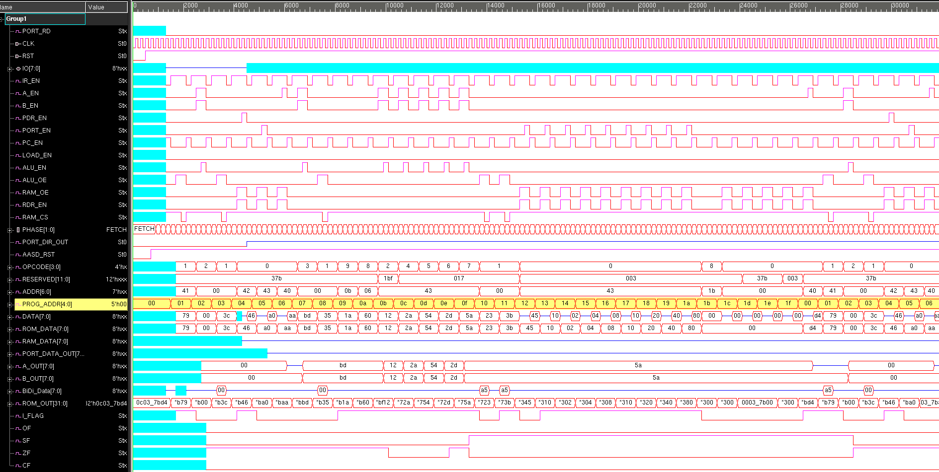

*Figure 1: Full Waveforms*

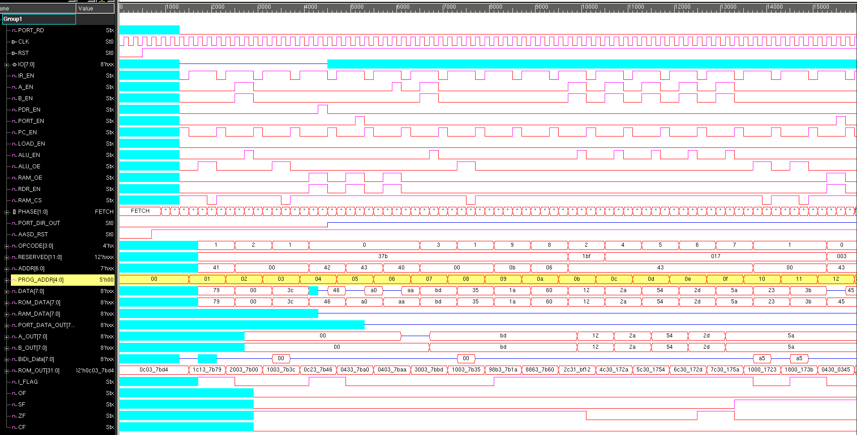

*Figure 2: Zoomed in, first half*

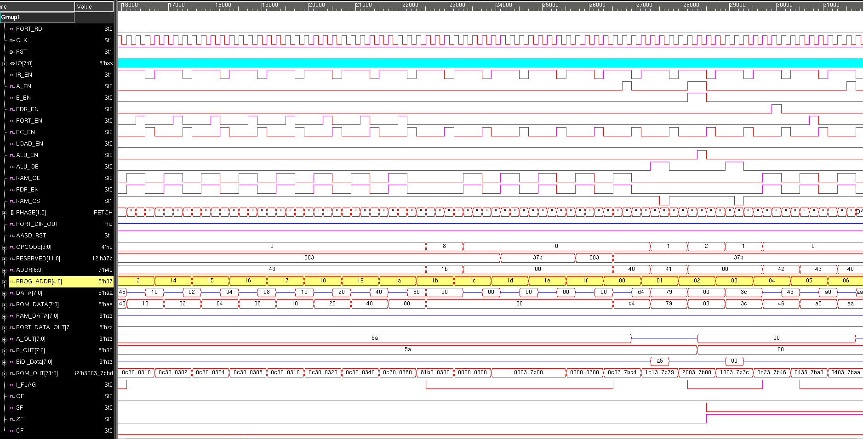

*Figure 3: Zoomed in, second half*

**Modules:**

**RISCY_CPU.sv**

/***********************************************************************

*** ECE526L Experiment #10 Garen Nikoyan, Spring 2018

*** Final Project: The RISC-Y Processor

************************************************************************

*** Filename: RISCY_CPU.sv Created by: Garen Nikoyan, 5/2/2018 ***

*** -Revision History

*** 5/2/2018: First draft

************************************************************************

*** This module instantiates various modules from previous labs in and

*** attempt to model a RISC processor. There are five main subsystems:

*** Memory, IO, ALU, Memory to Data Bus, and Sequence Controller.

************************************************************************/

`timescale 1ns/100ps

`default_nettype none

package cycle_package;

typedef enum [1:0] {FETCH = 0, DECODE = 1, EXECUTE = 2, UPDATE = 3} CYCLE;

endpackage

// ********** Top Level CPU

module RISCY(CLK,RST,IO);

import cycle_package::*;

input CLK, RST;

inout [7:0] IO;

wire IR_EN, A_EN, B_EN, PDR_EN, PORT_EN, PORT_RD, PC_EN, LOAD_EN, ALU_EN, ALU_OE, RAM_OE, RDR_EN, RAM_CS;

CYCLE PHASE;

wire PORT_DIR_OUT, AASD_RST;

wire [3:0] OPCODE;

wire [11:0] RESERVED;

wire [6:0] ADDR;

wire [4:0] PROG_ADDR;

wire [7:0] DATA, ROM_DATA, RAM_DATA, PORT_DATA_OUT, A_OUT, B_OUT;

wire [7:0] BiDi_Data, ALU_DATA;

wire [31:0] ROM_OUT;

wire I_FLAG, OF, SF, ZF, CF;

// Memory Subsystem

RAM RAM8(.DATA(BiDi_Data), .ADDR(ROM_DATA[4:0]), .OE(RAM_OE), .CS(RAM_CS), .WS(CLK));

SCALE_REG #(8) REG8(.REG_OUT(RAM_DATA), .DATA_IN(BiDi_Data), .EN(RDR_EN), .CLOCK(CLK));

ROM ROM32(.DATA(ROM_OUT), .ADDR(PROG_ADDR), .OE(1'b1), .CS(1'b0));

ProgCount #(5) PrgCnt(.Count(PROG_ADDR), .CLOCK(CLK), .RESET(AASD_RST), .Enable(PC_EN), .Load(LOAD_EN), .Data(ADDR[4:0]));

SCALE_REG #(32) REG32(.REG_OUT({OPCODE,I_FLAG, ADDR, RESERVED, ROM_DATA}), .DATA_IN(ROM_OUT), .EN(IR_EN), .CLOCK(CLK));

// IO Subsystem

PORT_DIR_REG PDR(.REG_OUT(PORT_DIR_OUT), .DATA_IN(DATA[0]), .PDR_EN(PDR_EN),.CLOCK(CLK), .RESET(AASD_RST));

SCALE_REG #(8) IOREG(.REG_OUT(PORT_DATA_OUT), .DATA_IN(DATA), .EN(PORT_EN), .CLOCK(CLK));

Tri_State_Buffer Port_Data(.OUT(IO), .A(PORT_DATA_OUT), .SEL(PORT_DIR_OUT));

Tri_State_Buffer Port_Read(.OUT(BiDi_Data), .A(IO), .SEL(PORT_RD));

// ALU Subsystem

SCALE_REG #(8) A_Reg(.REG_OUT(A_OUT), .DATA_IN(DATA), .EN(A_EN), .CLOCK(CLK));

SCALE_REG #(8) B_Reg(.REG_OUT(B_OUT), .DATA_IN(DATA), .EN(B_EN), .CLOCK(CLK));

ALU #(8) ALU0(.CLK(CLK), .EN(ALU_EN), .OE(ALU_OE), .OPCODE(OPCODE), .A(A_OUT), .B(B_OUT), .ALU_OUT(BiDi_Data), .CF(CF), .OF(OF), .SF(SF), .ZF(ZF));

// Memory to Data Bus Subsystem

scale_mux #(8) MUX(.A(ROM_DATA), .B(RAM_DATA), .SEL(RAM_OE), .OUT(DATA));

// Sequence Controller Subsystem

AASD AASD0(.AASD_RST(AASD_RST), .CLOCK(CLK), .RESET(RST));

phaser Phsr(.CLOCK(CLK), .RESET(AASD_RST), .EN(1'b0), .PHASE(PHASE));

sequence_controller SeqCtrl(.ADDR(ADDR), .OPCODE(OPCODE), .PHASE(PHASE), .I_FLAG(I_FLAG), .ZF(ZF), .NF(SF), .OF(OF), .CF(CF), .IR_EN(IR_EN), .A_EN(A_EN), .B_EN(B_EN), .PDR_EN(PDR_EN), .PORT_EN(PORT_EN), .PORT_RD(PORT_RD), .PC_EN(PC_EN), .PC_LOAD(LOAD_EN), .ALU_EN(ALU_EN), .ALU_OE(ALU_OE), .RAM_OE(RAM_OE), .RDR_EN(RDR_EN), .RAM_CS(RAM_CS));

endmodule

**sequence_controller.sv**

`timescale 1ns/100ps

`default_nettype none

package cycle_package;

typedef enum [1:0] {FETCH =0, DECODE = 1, EXECUTE = 2, UPDATE = 3} CYCLE;

endpackage

module sequence_controller(ADDR,OPCODE,PHASE,I_FLAG,ZF,NF,OF,CF,IR_EN,A_EN,B_EN,PDR_EN,PORT_EN,PORT_RD,PC_EN,PC_LOAD,ALU_EN,ALU_OE,RAM_OE,RDR_EN,RAM_CS);

import cycle_package::*;

input [6:0] ADDR;

input [3:0] OPCODE;

input CYCLE PHASE;

input I_FLAG,ZF,NF,OF,CF;

output reg IR_EN,A_EN,B_EN,PDR_EN,PORT_EN,PORT_RD,PC_EN,PC_LOAD,ALU_EN,ALU_OE,RAM_OE,RDR_EN,RAM_CS;

reg branches;

// Instruction set

localparam LOAD = 0,

STORE = 1,

ADD = 2,

SUB = 3,

AND = 4,

OR = 5,

XOR = 6,

NOT = 7,

B = 8,

BZ = 9,

BN = 10,

BV = 11,

BC = 12;

always @(PHASE,I_FLAG,ZF,NF,OF,CF,ADDR,OPCODE)

case (PHASE)

// FETCH

FETCH:

begin

IR_EN=1'b1;

PC_EN=1'b0;

end

// DECODE

DECODE:

begin

case (OPCODE)

LOAD:

begin

RAM_OE <= 1'b1;

RAM_CS <= 1'b1;

RDR_EN <= 1'b1;

end

STORE:

begin

if(ADDR==67) PORT_RD <= 1'b1;

else ALU_OE <= 1'b1;

end

ADD:

begin

A_EN = 1'b1;

B_EN = 1'b1;

end

SUB:

begin

A_EN = 1'b1;

B_EN = 1'b1;

end

AND:

begin

A_EN = 1'b1;

B_EN = 1'b1;

end

OR:

begin

A_EN = 1'b1;

B_EN = 1'b1;

end

XOR:

begin

A_EN = 1'b1;

B_EN = 1'b1;

end

NOT:

begin

A_EN = 1'b1;

B_EN = 1'b1;

end

endcase

end

// EXECUTE

EXECUTE:

begin

case (OPCODE)

LOAD:

begin

case (ADDR)

64: A_EN = 1'b1;

65: B_EN =1'b1;

66: PDR_EN <=1'b1;

67: PORT_EN <=1'b1;

endcase

end

STORE:

begin

RAM_CS <= 1'b0;

end

ADD:

begin

ALU_EN <=1'b1;

end

SUB:

begin

ALU_EN <=1'b1;

end

AND:

begin

ALU_EN <=1'b1;

end

OR:

begin

ALU_EN <=1'b1;

end

XOR:

begin

ALU_EN <=1'b1;

end

NOT:

begin

ALU_EN <=1'b1;

end

endcase

end

// UPDATE

UPDATE: begin

case(OPCODE)

B: PC_LOAD=1'b1;

BZ: PC_LOAD=ZF;

BN: PC_LOAD=NF;

BV: PC_LOAD=OF;

BC: PC_LOAD=CF;

default: PC_LOAD=1'b0;

endcase

IR_EN <= 1'b0;

A_EN = 1'b0;

B_EN = 1'b0;

PDR_EN <= 1'b0;

PORT_EN <= 1'b0;

PORT_RD <= 1'b0;

ALU_EN <= 1'b0;

ALU_OE <= 1'b0;

RAM_OE <= 1'b0;

RDR_EN <= 1'b0;

PC_EN=1'b1;

PC_LOAD=1'b0;

RAM_CS <= 1'b1;

end

// DEFAULT

default: begin

IR_EN <= 1'b0;

A_EN = 1'b0;

B_EN = 1'b0;

PDR_EN <= 1'b0;

PORT_EN <= 1'b0;

PORT_RD <= 1'b0;

ALU_EN <= 1'b0;

ALU_OE <= 1'b0;

RAM_OE <= 1'b0;

RDR_EN <= 1'b0;

PC_EN=1'b0;

PC_LOAD=1'b0;

RAM_CS <= 1'b1;

end

endcase

endmodule

**phaser.sv**

`timescale 1ns/100ps

`default_nettype none

package cycle_package;

typedef enum [1:0] {FETCH =0, DECODE = 1, EXECUTE = 2, UPDATE = 3} CYCLE;

endpackage

module phaser(CLOCK, RESET, EN, PHASE);

import cycle_package::*;

input CLOCK, RESET, EN;

output CYCLE PHASE;

always @(posedge CLOCK, negedge RESET) begin

if(!RESET)

PHASE <= PHASE.first();

else if(!EN)

PHASE <= PHASE.next();

else

PHASE <= PHASE;

end

endmodule

**AASD.sv**

`timescale 1ns/100ps

`default_nettype none

package cycle_package;

typedef enum [1:0] {FETCH =0, DECODE = 1, EXECUTE = 2, UPDATE = 3} CYCLE;

endpackage

module AASD(AASD_RST,CLOCK,RESET);

output reg AASD_RST;

input CLOCK,RESET;

reg Out1; //this is the wire for the output of the first FF

always @ (posedge CLOCK or negedge RESET) //allows 4 synchronous/asynchronous

if(!RESET)begin//asynchronous reset

Out1 <= 1'b0;

AASD_RST <= 1'b0;

end

else begin

Out1 <= 1'b1;

AASD_RST <= Out1;

end

endmodule

**RAM.sv**

`timescale 1ns/100ps

`default_nettype none

package cycle_package;

typedef enum [1:0] {FETCH =0, DECODE = 1, EXECUTE = 2, UPDATE = 3} CYCLE;

endpackage

module RAM(DATA, ADDR, OE, CS, WS);

inout [7:0] DATA;

input [4:0] ADDR;

input OE, CS, WS;

reg [7:0] memory [0:31];

// if OE=1 and CS=0, DATA=memory at ADDR; if not, DATA=z

// assign is used because of inout type

assign DATA = (OE && !CS) ? memory[ADDR] : 8'bz;

always@(posedge WS) begin

if (!OE && !CS)

memory[ADDR] <= DATA;

else

memory[ADDR] <= memory[ADDR]; // to prevent latches in hardware

end

endmodule

**ROM.sv**

`timescale 1ns/100ps

`default_nettype none

package cycle_package;

typedef enum [1:0] {FETCH =0, DECODE = 1, EXECUTE = 2, UPDATE = 3} CYCLE;

endpackage

module ROM(DATA, ADDR, OE, CS);

output reg [31:0] DATA;

input wire [4:0] ADDR;

input OE, CS;

reg [31:0] memory [0:31];

// if OE=1 and CS=0, DATA=memory at ADDR; if not, DATA=z

always@* DATA = (OE && !CS) ? memory[ADDR] : 32'bz;

endmodule

**SCALE_REG.sv**

`timescale 1ns/100ps

`default_nettype none

package cycle_package;

typedef enum [1:0] {FETCH =0, DECODE = 1, EXECUTE = 2, UPDATE = 3} CYCLE;

endpackage

module SCALE_REG(REG_OUT,DATA_IN,EN,CLOCK);

parameter RegSize = 1;

output reg [ RegSize - 1 : 0] REG_OUT;

input reg [ RegSize - 1 : 0] DATA_IN;

input CLOCK,EN;

always @ (posedge CLOCK) begin

if(EN)

REG_OUT <= DATA_IN;

else

REG_OUT <= REG_OUT;

end

endmodule

**PORT_DIR_REG.sv**

`timescale 1ns/100ps

`default_nettype none

package cycle_package;

typedef enum [1:0] {FETCH =0, DECODE = 1, EXECUTE = 2, UPDATE = 3} CYCLE;

endpackage

module PORT_DIR_REG(REG_OUT,DATA_IN,PDR_EN,CLOCK,RESET);

output reg REG_OUT;

input reg DATA_IN; // DATA[0]

input CLOCK,RESET,PDR_EN;

always @ (posedge CLOCK or negedge RESET) begin

if(PDR_EN)

REG_OUT <= DATA_IN;

else if (!RESET)

REG_OUT <= 0;

else

REG_OUT <= REG_OUT;

end

endmodule

**Tri_State_Buffer.sv**

`timescale 1ns/100ps

`default_nettype none

package cycle_package;

typedef enum [1:0] {FETCH =0, DECODE = 1, EXECUTE = 2, UPDATE = 3} CYCLE;

endpackage

module Tri_State_Buffer(OUT, A, SEL);

input [7:0] A;

input SEL;

inout [7:0] OUT;

assign OUT = SEL ? A : 8'bz; //first tri state buffer

endmodule

**ProgCount.sv**

`timescale 1ns/100ps

`default_nettype none

package cycle_package;

typedef enum [1:0] {FETCH =0, DECODE = 1, EXECUTE = 2, UPDATE = 3} CYCLE;

endpackage

module ProgCount(Count, CLOCK, RESET, Enable, Load, Data);

parameter PCSize = 1;

output reg [PCSize-1:0] Count;

input [PCSize-1:0] Data;

input CLOCK, Enable, RESET, Load;

always @ (posedge CLOCK or negedge RESET)

if(!RESET)

Count <= 0;

else if(Enable)

begin

if(Load)

Count <= Data;

else

Count <= Count+ 1;

end

endmodule

**scale_mux.sv**

`timescale 1ns/100ps

`default_nettype none

package cycle_package;

typedef enum [1:0] {FETCH =0, DECODE = 1, EXECUTE = 2, UPDATE = 3} CYCLE;

endpackage

module scale_mux(A, B, SEL, OUT);

parameter Size = 1;

output reg [Size-1:0] OUT;

input [Size-1:0] A, B;

input SEL;

always @(SEL, A, B)

OUT = SEL ? B : A; // if SEL=1, OUT=B, if SEL=0, OUT=A

// if SEL=x, then A=B causes OUT=A=B, and A!=B, OUT=x

endmodule

**ALU.sv**

`timescale 1ns/100ps

`default_nettype none

package cycle_package;

typedef enum [1:0] {FETCH =0, DECODE = 1, EXECUTE = 2, UPDATE = 3} CYCLE;

endpackage

module ALU(CLK, EN, OE, OPCODE, A, B, ALU_OUT, CF, OF, SF, ZF);

parameter WIDTH = 8;

output reg [ WIDTH-1 : 0] ALU_OUT;

output reg CF, OF, SF, ZF;

input [3:0] OPCODE;

input [ WIDTH-1 : 0] A, B;

input reg CLK, EN, OE;

reg [ WIDTH-1 : 0] temp;

localparam ADDalu = 4'b0010,

SUBalu = 4'b0011,

ANDalu = 4'b0100,

ORalu = 4'b0101,

XORalu = 4'b0110,

NOTalu = 4'b0111;

always @(OE, temp) ALU_OUT = (OE) ? temp : 8'bz;

always @(posedge CLK) begin

if(EN) begin

case (OPCODE)

ADDalu: begin

temp = A + B;

// Carry Flag

if (A+B> 2**WIDTH -1) CF=1;

else CF=0;

// Signed Flag

if (temp[WIDTH-1]==1) SF=1;

else SF=0;

// Zero Flag

if(temp==0) ZF=1;

else ZF=0;

// Overflow Flag

if(A>0 && B>0 && temp<0) OF=1;

else if (A<0 && B<0 && temp>0) OF=1;

else OF=0;

end

SUBalu: begin

temp = A - B;

// Carry Flag

if (A<B) CF=1;

else CF=0;

// Signed Flag

if (temp[WIDTH-1]==1) SF=1;

else SF=0;

// Zero Flag

if(temp==0) ZF=1;

else ZF=0;

// Overflow Flag

if(A>0 && B>0 && temp<0) OF=1;

else if (A<0 && B<0 && temp>0) OF=1;

else OF=0;

end

ANDalu: begin

temp = A&B;

// Signed Flag

if(temp[WIDTH-1]==1) SF=1;

else SF=0;

// Zero Flag

if(temp==0) ZF=1;

else ZF=0;

end

ORalu: begin

temp = A|B;

// Signed Flag

if(temp[WIDTH-1]==1) SF=1;

else SF=0;

// Zero Flag

if(temp==0) ZF=1;

else ZF=0;

end

XORalu: begin

temp = A^B;

// Signed Flag

if(temp[WIDTH-1]==1) SF=1;

else SF=0;

// Zero Flag

if(temp==0) ZF=1;

else ZF=0;

end

NOTalu: begin

temp = ~A;

// Signed Flag

if(temp[WIDTH-1]==1) SF=1;

else SF=0;

// Zero Flag

if(temp==0) ZF=1;

else ZF=0;

end

default: temp = 1'bx;

endcase

end

end

endmodule

**Testbench:**

**RISCY_TB.sv**

`timescale 1ns/100ps

module RISCY_TB();

reg CLK, RST;

wire [7:0] IO;

reg [7:0] Data_In;

integer i;

RISCY UUT(CLK, RST, IO);

initial CLK = 1'b0;

always #10 CLK = !CLK;

assign IO = UUT.PORT_RD ? Data_In: 'bz;

initial begin

$vcdpluson;

$readmemh("ROM_DATA.txt", UUT.ROM32.memory);

end

initial begin

RST = 1'b0; Data_In = 8'h55;

#50 RST = 1'b1;

#2000

$display("\t RAM Address || Contents");

for(i=0; i<32; i=i+1) begin

#20 $display("\t %2h | %2h ", i, UUT.ROM32.memory[i]);

end

$finish;

end

endmodule

**ROM_DATA.txt**

00001100000000110111101111010100

00011100000100110111101101111001

00100000000000110111101100000000

00010000000000110111101100111100

00001100001000110111101101000110

00000100001100110111101110100000

00000100000000110111101110101010

00110000000000110111101110111101

00010000000000110111101100110101

10011000101100110111101100011010

10001000011000110111101101100000

00101100001100011011111100010010

01001100001100000001011100101010

01011100001100000001011101010100

01101100001100000001011100101101

01111100001100000001011101011010

00010000000000000001011100100011

00011000000000000001011100111011

00000100001100000000001101000101

00001100001100000000001100010000

00001100001100000000001100000010

00001100001100000000001100000100

00001100001100000000001100001000

00001100001100000000001100010000

00001100001100000000001100100000

00001100001100000000001101000000

00001100001100000000001110000000

10000001101100000000001100000000

00000000000000000000001100000000

00000000000000110111101100000000

00000000000000110111101100000000

00000000000000000000001100000000

**Conclusion:**

This lab, besides being the most difficult, was also the most enlightening. Trying to instantiate so many modules while keeping track of all the connections proved to be very difficult, and tracking down errors required a very deep understanding of not only the hardware description, but also of what was expected. In conclusion, this lab tied what I think was the most important takeaways from this class all into one, by including such a large number of modules into one design.